**Artistic Reflections with Elegant Decorative Mirrors**

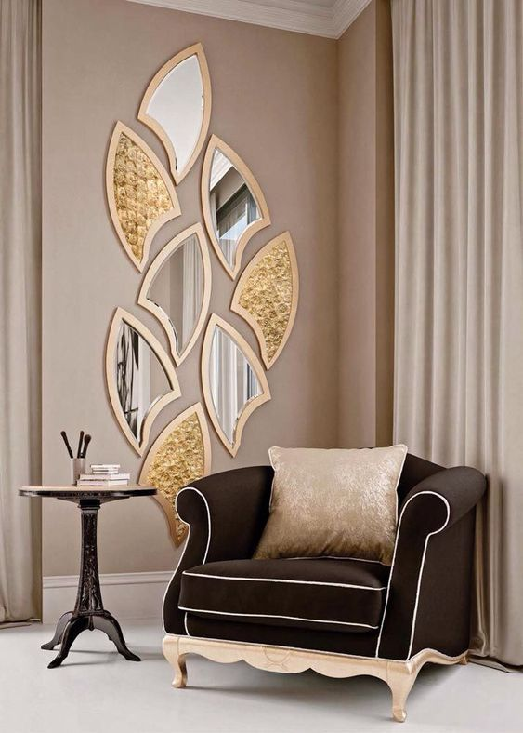

Decorative Mirrors go beyond function — they are pieces of art that elevate your interior design. With intricate frames, creative shapes, and ornate details, these mirrors serve as stunning focal points that reflect both light and personality.

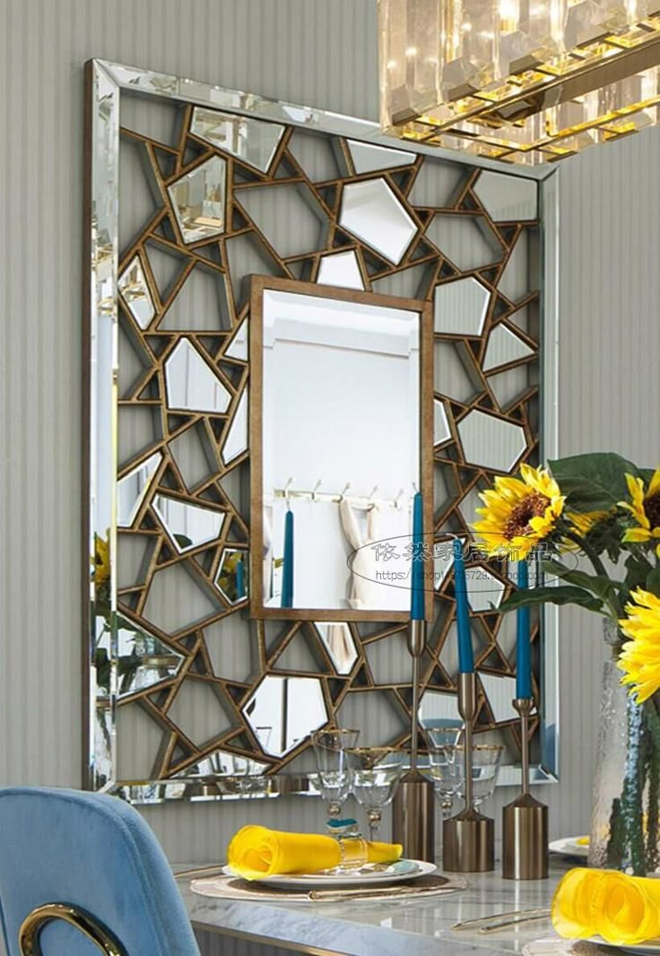From vintage-inspired carvings to modern geometric patterns, each decorative mirror is crafted to add beauty and charm to your walls. They’re perfect for living rooms, hallways, and bedrooms where you want to make a statement without saying a word.

These mirrors not only enhance the sense of space and brightness but also showcase your unique style. Whether you prefer classic opulence or contemporary flair, a decorative mirror is the perfect way to express elegance and individuality in your home.

Transform empty walls into expressions of taste and creativity with mirrors that do more than just reflect — they inspire.